**Ideation Phase**

**Empathize & Discover**

|  |  |
| --- | --- |
| Date | 28 June 2025 |
| Team ID | LTVIP2025TMID40768 |
| Project Name | Traffictelligence |
| Maximum Marks | 4 Marks |

**Empathy Map Canvas:**

* A visualization tool to understand user behaviors, needs and challenges for human-centered design solutions.
* An empathy map is a simple, easy-to-digest visual that captures knowledge about a user’s behaviours and attitudes.
* It is a useful tool to helps teams better understand their users.

Creating an effective solution requires understanding the true problem and the person who is experiencing it. The exercise of creating the map helps participants consider things from the user’s perspective along with his or her goals and challenges.

**Objective:**  
Understand the evolving needs of modern commuters to design more effective traffic intelligence solutions.

**Example:**

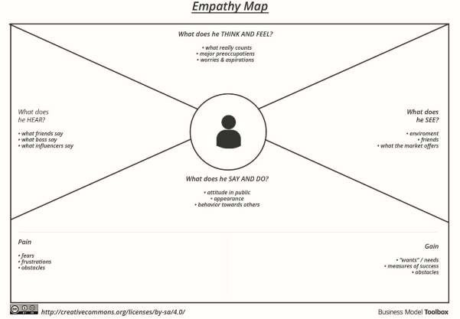

|  |  |
| --- | --- |
| **What does he feel and think** | **Traffic problems** |
| **What does he see** | Traffic jams , stuck in vehicles |
| **What does he hear** | Vehicle sounds and boring radio |
| **What does he do** | Gets frustrated or sad |
| **Pains**  **Delay in actions Traffic jams** | Gains  Application to predict traffic volume |